Fennimore Volleyball Pink Night
Ordered By_________________________________________________________ Phone _______________________________

 |  |  | ADULT
CODE | GARMENT |  | S | M | L | XL | 2X | 3X | TOTAL
A | Heat Transfer Gildan Short Sleeve T Shirt  Graphite Heather | $12.00 S-XL  $14.00 2X-3X
 | Heat Transfer Gildan Short Sleeve T Shirt  Heathered Purple | $12.00 S-XL  $14.00 2X-3X
B | Heat Transfer Gildan Long Sleeve T Shirt  Graphite Heather | $15.00 S-XL  $18.00 2X-3X
C | Port Authority Allie Tote - Black | $15.00
D | Port Authority Canvas Sling Bag - Black | $15.00
Please return to Coaches or Deanna Gunderson by Sept. 13 |  |  |  |  |  |  | GRAND TOTAL

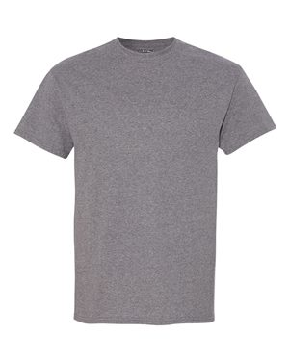
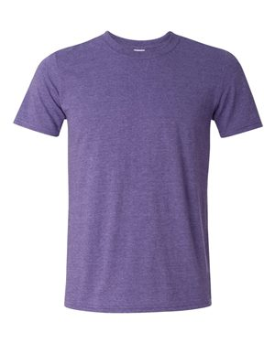

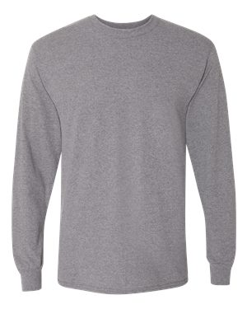
B
A

Left Chest

Shirt back
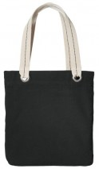
Shirt Back D
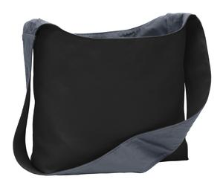
C D

689 Lincoln Avenue Fennimore, WI 53809
Phone: 608-822-3600 – Fax: 608-822-3000

Business Hours
Monday 9 to 5 All order must be prepaid
Tuesday 9 to 5
Wednesday 9 to 5 Make Checks payable to: Fennimore Volleyball Club
Thursday 9 to 5 All proceeds are donated to the Grant County Cancer Coalition
By Appt. 5 to 7
Friday 9 to 5
Once garments are customized they are not returnable. PAID Check _____________ Cash ___________

